Coronary circulation:
Coronary circulation is the circulation of blood in the blood vessels that supply the heart muscle (myocardium). Coronary arteries supply oxygenated blood to the heart muscle, and cardiac veins drain away the blood once it has been deoxygenated. Coronary circulation is a part of systemic circulation. The cardiac muscles are supplied by the two coronary
arteries ;
- The right coronary arteries
- The left coronary arteries
Both the arteries arises from the sinuses behind the cups of the aortic valves at the root of aorta.
- Left coronary artery (LCA): Left anterior descending/interventricular artery. Left circumflex artery& Ramus or intermediate artery(some times). Sometimes, an additional artery arises at the bifurcation of the left main artery, forming a trifurcation; this extra artery is called the ramus or intermediate artery
- Right coronary artery (RCA): Right marginal artery. Posterior descending artery/posterior interventricular artery.
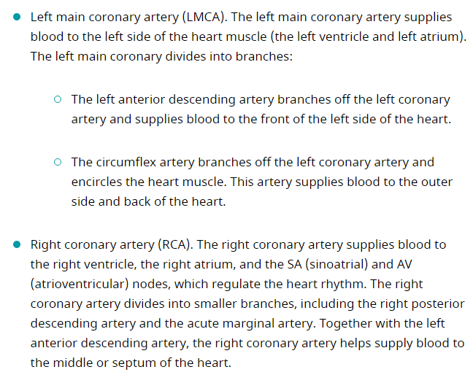

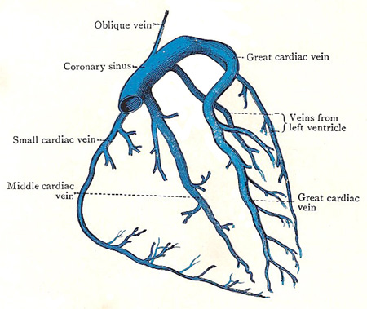
The venous drainage consists of
- coronary sinus
- Anterior cardiac veins
- venae cordis minimae

A coronary vein/cardiac vein is any of the veins that return the blood from the tissues of the heart that open into the right atrium either directly or through the coronary sinus.

A little of the venous blood in the walls of the heart is collected by very small veins called the venae cordis minimae, which lie in the walls and open directly in the chambers of the heart, chiefly the right atrium. But most of the blood is collected by veins that form networks on the surface of the heart. These networks are drained by the anterior cardiac veins and the tributaries of the cardiac sinus.

The anterior cardiac veins are small vessels which course over the anterior surface of the right ventricle and atrium, and enter the right atrium near the atrio-ventricular groove.

The coronary sinus runs from left to right in the posterior part of the atrio-ventricular groove, between the left atrium and the left ventricle. Its right extremity opens into the right atrium immediately to the left of the orifice of the inferior vena cava. At its left extremity it receives the great cardiac vein.

The great cardiac vein ascends in the anterior interventricular groove, alongside the interventricular branch of the left coronary artery. At the upper end of the groove, it turns to the left and then runs backward and downward in the left part of the atrio-ventricular groove, with the left coronary artery – the blood flowing in the same direction in the two vessels; and it ends in the left extremity of the coronary sinus. The small cardiac vein runs from left to right along the lower margin of the heart, curves round the right border of the heart, in the atrio-ventricular groove, and ends in the coronary sinus near its termination. The middle cardiac vein runs backward in the inferior interventricular groove and also ends in the coronary sinus near its termination.

The oblique vein of the left atrium is a slender vessel that descends over the posterior wall of the left atrium and ends in the coronary sinus about its middle. It is of developmental interest because it represents the terminal part of a left superior vena cava that existed in early fetal life.

A valve is located at the junction of the great cardiac vein and the coronary sinus; and the orifice of the small cardiac vein may also have a valve; but the orifices of the other tributaries of the sinus are generally devoid of valves.

